‘Our Community, Our Park’ - The Friends of Woodfield Park Project, St Catherine’s Hospital, Doncaster
‘Our Community, Our Park’ is building on a project the Centre for Sustainable Healthcare (CSH) and local volunteers carried out between 2011 and 2013 in Balby, Doncaster to make green space accessible to community members at a site adjacent to the former St Catherine's Hospital. A local community group - The Friends of Woodfield Park - grew out of this project, with the aim of carrying out activities to benefit more members of the community.
CSH secured a grant from People’s Health Trust to support this work, using money raised by HealthRich, one of 51 Community Interest Companies raising money to address health inequalities across England, Scotland and Wales through The Health Lottery. As part of this project, the Friends of Woodfield Park are running sociable events to build community links such as a regular coffee mornings and seasonal celebrations and healthy outdoor activities, such as walks in the beautiful green space surrounding the former hospital buildings. They are also coordinating arts activities between a primary school, Woodfield School, and Doncaster Arts (darts).
Every week in term-time, 12 children at Woodfield School are taking part in environmental arts to inspire them with a love of nature and to engage them and their families with the benefits of being outdoors for their long-term health and wellbeing. So far, the children have tried their hand at ceramics, photography and even sculpture-building – resulting in the creation of giant wooden spiders and colourful beetles which now festoon the school grounds!
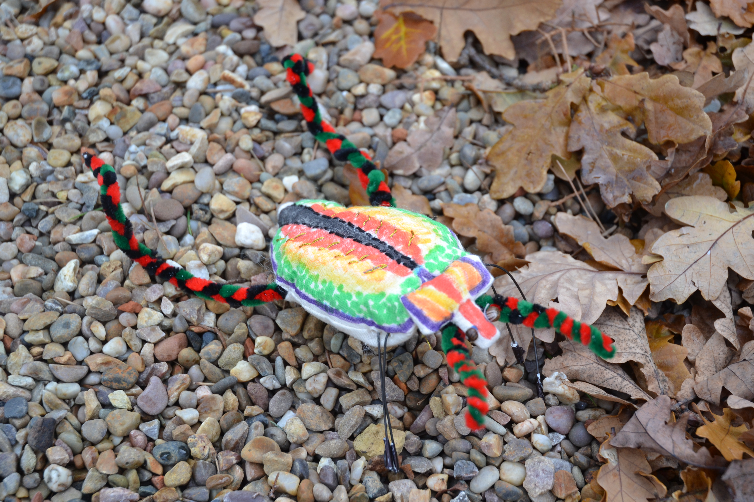
They have also had the chance to gain a Trinity College London Arts Award by taking part in the activities, and their work has recently been featured on the website of the Saatchi Gallery as part of their Art Prize for Schools. You can see some of the children’s wonderful creations featured on the gallery website here – just click on the pictures to find out more about each artwork : http://www.saatchigallery.com/portfolio/SchoolInfo/Woodfield+Primary+School/529.html
The children involved say that their confidence has increased and that they feel that they are making a positive contribution with their creations, as their comments bear out: "Our friends say the things we make are amazing and that makes me feel happy", (Ashleigh); "It's great to have a chance to work on new things -- it's a big surprise how to do art! I get excited before each session", (Jada); and "We're learning new skills - drawing with our eyes closed, using saws and drills, working with needles on textiles", (Lucy).

More children are set to join the scheme over the course of the year, and to have the opportunity to take further Arts Awards. In the meantime – watch out for the giant bugs!
For more information contact The Centre for Sustainable Healthcare – 01865 515811; http://nhsforest.org/st-catherines-hospital-doncaster

